Lab Practical #01:
Study of basic networking commands and IP configuration.
Practical Assignment #01:
- Perform and explain various networking commands listed below:
  - ipconfig
  - ping
  - getmac
  - systeminfo
  - traceroute / tracert
  - netstat
  - nslookup
  - hostname
  - pathping
  - arp

ipconfig

Description:
--------- Details About Command ------
No. | Option | Description
1 | /all | Displays full configuration information for all network adapters.
2 | /renew | Renews the IP address for all adapters .
3 |  | Clears the DNS resolver cache.
  /flushdns
4 |  | Displays the contents of the DNS resolver cache.
  /displaydns
5 |  | Releases the current IP address for all adapters
  /release

Implementation:----- Screenshot Only (Execute command on command prompt / terminal) -----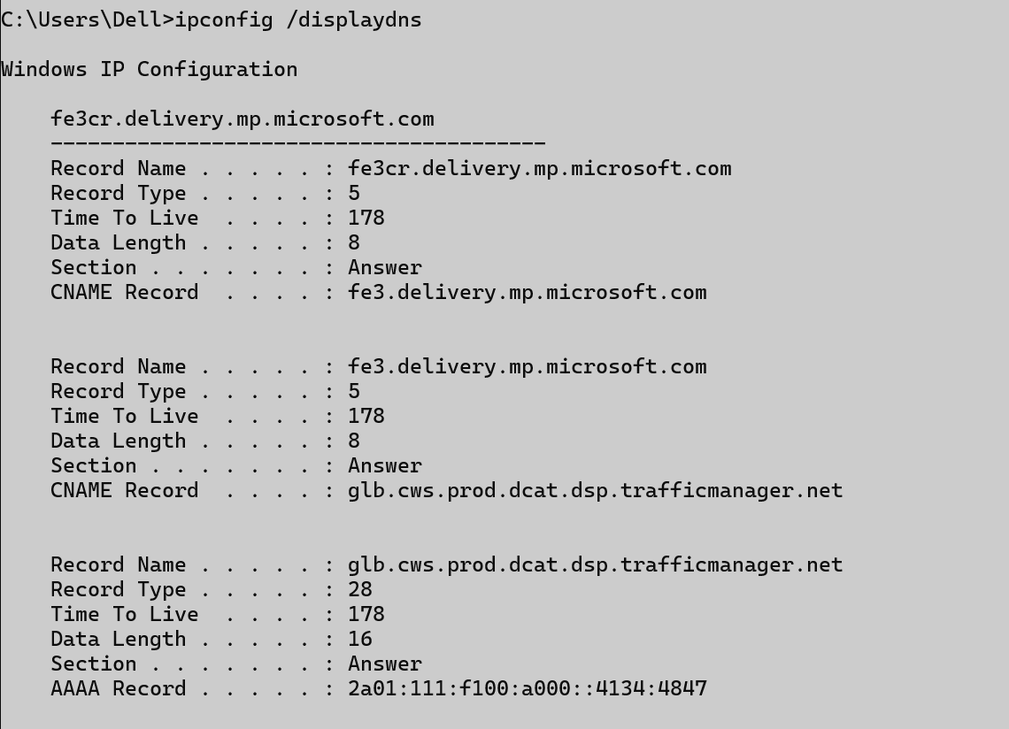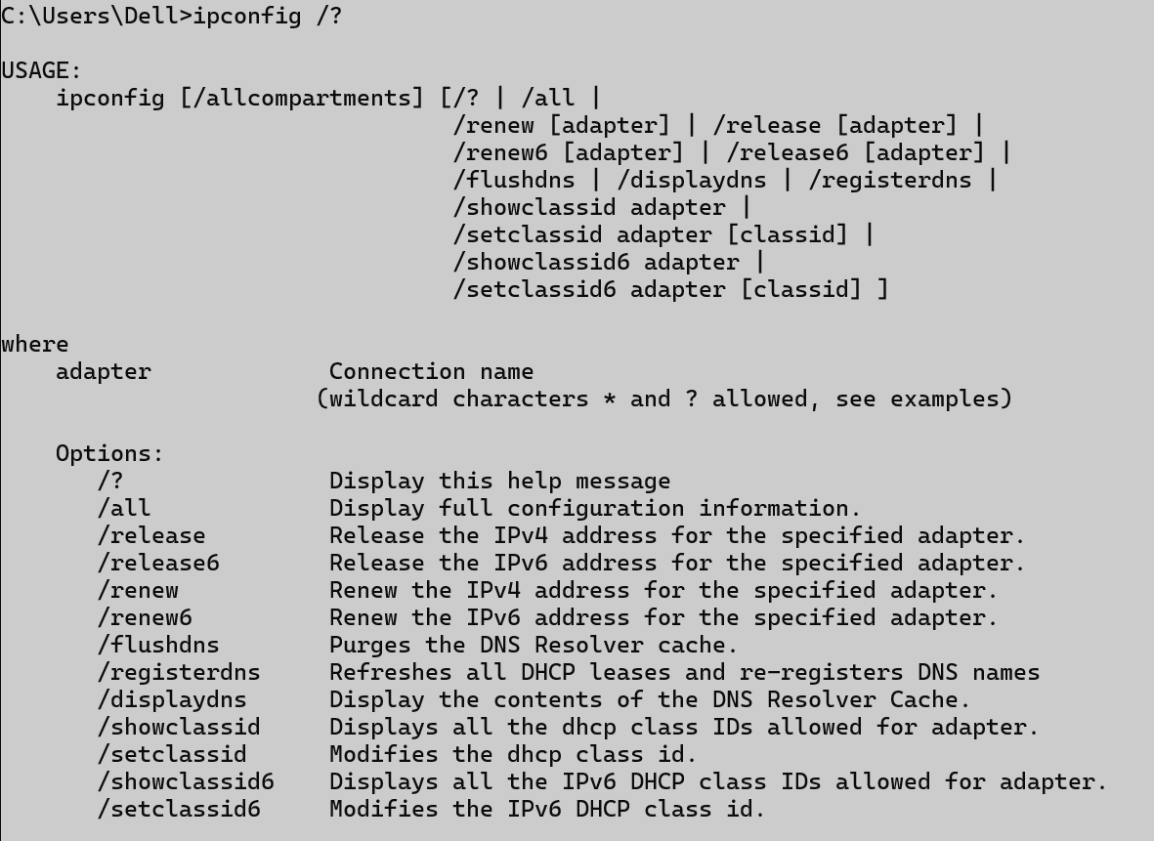

ping

Description:
--------- Details About Command ------
No. | Option | Description
1 | -n <count> | Sends a specific number of echo requests
2 | -t | Pings the target until manually stopped
3 |  | Resolves addresses to hostnames.
  -a
4 |  | Sends packets of a specified size in bytes
  -l <size>
5 | -w <timeout>
  Specifies a timeout in milliseconds to wait for each reply.

Implementation:
----- ScreenshotOnly (Execute command on command prompt / terminal) -----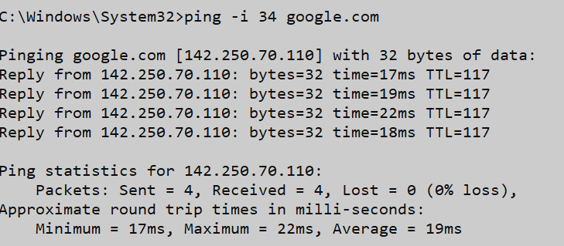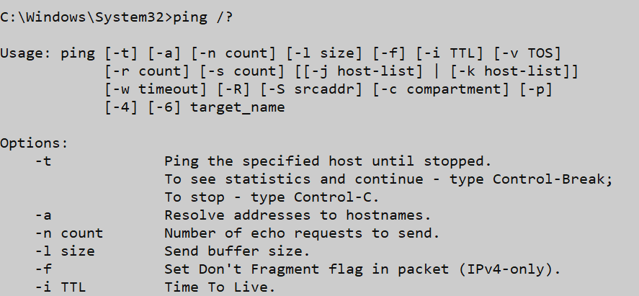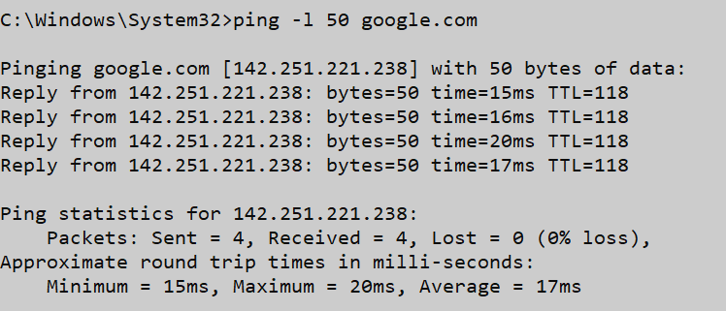

getmac

Description:
--------- Details About Command ------
No. | Option | Description
1 | /S system | Specifies the remote system to connect to.
2 | /U [domain\]user | Specifies the user context under  which the command should execute.
3 |  | Specifies the password for the given  user context. Prompts for input if omitted.
  /P [password]
4 |  | Specifies that verbose output is displayed.
  /V
5 | /NH
  Specifies that the "Column Header" should
  not be displayed in the output.Valid only for TABLE and CSV formats.

Implementation:
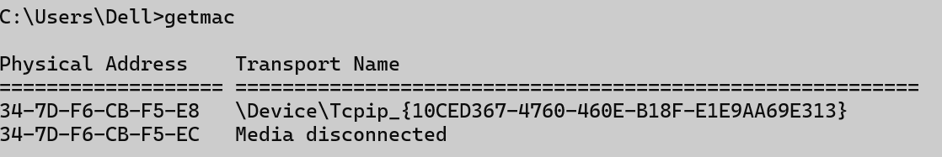

tracert

Description:
--------- Details About Command ------
No. | Option | Description
1 | -d | Do not resolve addresses to hostnames.
2 | -R | Trace round-trip path (IPv6-only).
3 |  | Maximum number of hops to search for target.
  -h maximum_hops
4 |  | Sends packets of a specified size in bytes
  -j host-list
5 | -w <timeout>
  Wait timeout milliseconds for each reply.

Implementation:
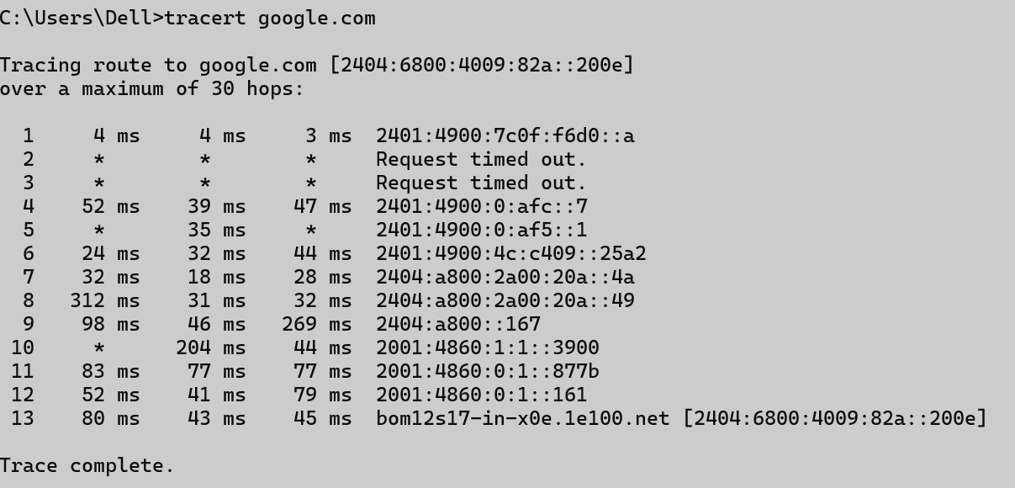

netstat

Implementation:
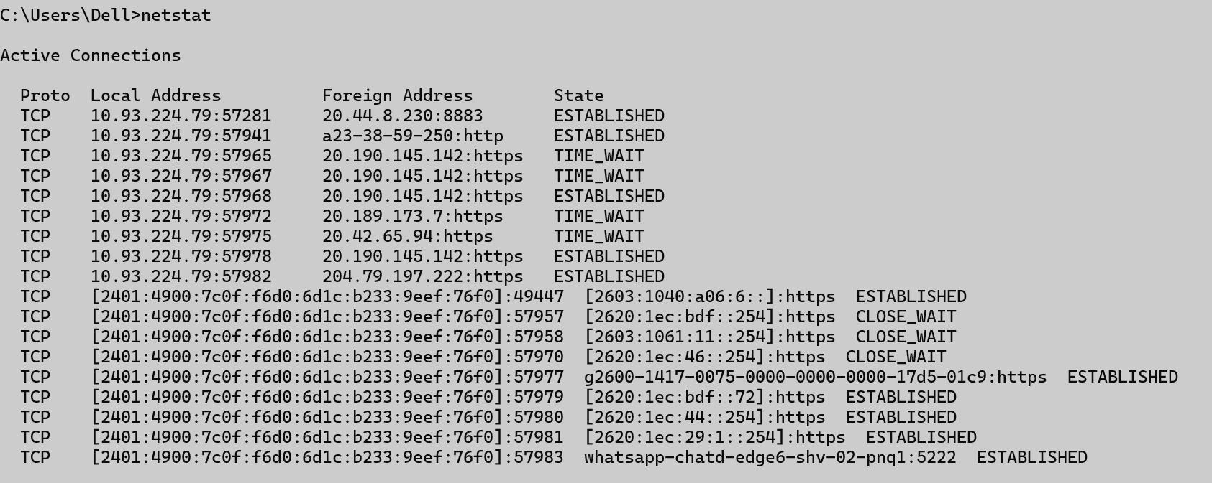

nslookup

Implementation:
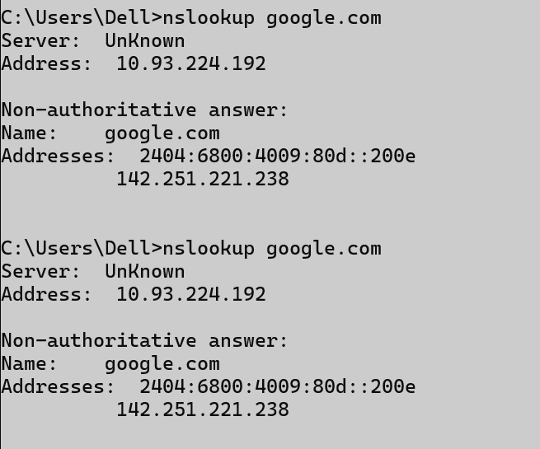

hostname

Implementation:


pathping

Description:
--------- Details About Command ------
No. | Option | Description
1 | -g host-list | Loose source route along host-list.
2 | -h maximum_hops | Maximum number of hops to search for target.
3 |  | Use the specified source address.
  -i address
4 |  | Do not resolve addresses to hostnames.
  -n
5 | -w <timeout>
  Wait timeout milliseconds for each reply.

Implementation:
